  - ASSESSMENT OBJECTIVES
The end of Cycle assessment for Geography will be guided by four assessment objectives focusing on the learner’s ability to:

AO1: Apply knowledge of geomorphic processes, geographic tools and techniques to assess development opportunities and address challenges in a given area.

AO2: Devise innovative ways of responding to challenges resulting from extreme weather events, climate variability and climate change through applying knowledge of atmospheric processes, geographic tools and techniques.

AO3: Design effective plans for promoting development in specific places by analysing development patterns, population, settlement and production systems using geographic tools and techniques.

AO4: Devise innovative strategies for sustainable utilisation of natural resources based on the context, using geographical tools and techniques.

3.0

3.0 STRUCTURE OF THE EXAMINATION PAPERS
There will be two examination papers for Geography at ASC. Each examination paper will be divided into two sections, with each section addressing specific assessment objectives.

Paper 1, Physical Geography, will contain two sections A and B. Section A will be compulsory; assessing the learner’s ability to apply geographic skills and tools to analysing problems related to physical environments. Items in Section A will come from constructs 1and 2 (Geomorphic processes and their impacts; and Weather and Climate Systems)
addressing assessment objectives 1and 2, while items from Section B will come from both constructs 1and 2 (Geomorphic processes and their impacts; and Weather and Climate Systems) addressing assessment objectives 1and 2. The items in the paper will be scenario based and the entire paper will take 2hours and 45 mins
Paper 2, Human Geography, will contain two sections A and B. Section A will be compulsory; assessing the learner’s ability to apply geographic skills and tools to analysing problems related to human geography. Items in Section A will come from constructs 3 (Human – Environment Interaction) and 4 (Sustainable utilisation of natural resources) addressing assessment objective 3, and 4. Section B will consist of two parts, I and II. Items in Part I will come from construct 3 addressing assessment objective 3 while items in Part II will come from construct 4 addressing assessment objective 4. The items in the paper will be scenario based and the entire paper will take 2hours and 40 mins.

SAMPLE TEST PAPERS

P250/1
GEOGRAPHY
Paper 1
November/December, 2025
3 hours

Uganda Advanced Certificate of Education
Geography
Paper 1

Physical Geography
3 hours

INSTRUCTIONS TO CANDIDATES:
This paper consists of two sections; A and B.
Section A is compulsory
Section B has two parts; I and II. Attempt one item from each part.
Attempt three items in all.
You may use sketch maps, diagrams and statistics, where applicable, to illustrate your answers.
Any additional item(s) attempted will not be scored.
All responses must be written in the answer booklet(s) provided

ADVICE
- Read the whole test item before answering it-especially if it is made up of more than one part.
- If you finish early, check your answers.

SECTION A
Application of Geographic Tools and Techniques to analysing Physical Environments

Item 1:
For this item, use the 1:50,000 Uganda Map Extract of Nsika, Series Y732, Sheet 76/4, Edition 3-U.S. D (Insert).

The local government in Nsika is planning to develop a new housing estate on the slopes of Kyamuzhumi hill between Eastings 14 and 16, and north of Northing 54. However, the most recent heavy rains in the have caused several landslides in the area. This has raised concerns about the stability of the hill slopes and the possible risks to human life, infrastructure and other developments.

As a geomorphologist, you have been requested to conduct a detailed analysis of the hill slopes to provide information that will guide the development plan. Your analysis is expected to include details about the nature and stability of the slope, which is very important in assessing hazard risk and in devising measures to overcome the associated challenges.

Map Extract: NSIKA, Series Y732, Sheet 76/4, Edition 3-U.S.D. [Cut Extract from Easting 11 to 20, Northing 49 to 60)l

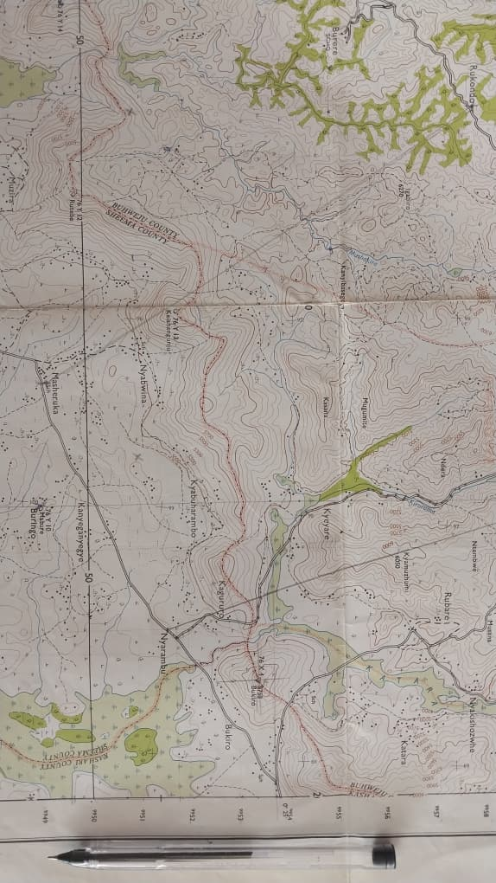

Tasks:
Write a report about the area and in it include:
- A cross section of the area shown on the map between grid references 145550 and 160500; and on it mark and name the relief features, drainage features and land use types.
- Advice, based on the cross section you have drawn, on whether the Local government should go ahead to develop a housing estate on this hill slope or not.
- Possible measures which can be taken to reduce the occurrence of any one natural hazard that can affect the area shown on the map as a result of its relief.

SECTION B
Geomorphic Processes and their Impacts

Part I
Attempt one item from this part.
Item 2: Study the text and Fig.1 below; then do the task that follows.
There is increasing interest among people to understand the world they live in and its e natural resources. Both Science and religion have tried to explain this; yet many still wonder why the world is made up of very large landmasses separated by water bodies. People are also interested in understanding why natural resources are unevenly distributed.
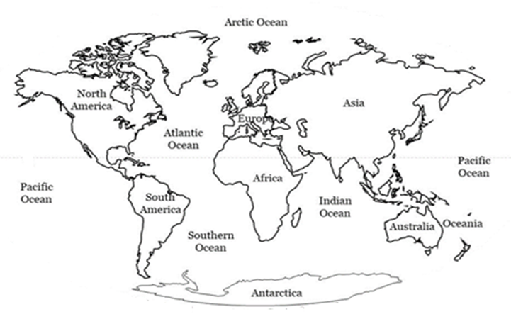
Fig. 1: The World
This search for deeper understanding has led to the development of two groups of people with different ways of thinking. One group believes that the huge landmasses and all the waters separating them were created by God who gathered the waters to create dry land and made all other resources found on the surface, underground, and in the seas. Another group believes that the landmasses and water bodies separating them were formed by natural physical processes that occur within the Earth.
These differing views have attracted the attention of the National Geographical Society (NGS); which is consequently organising a national conference to help people better understand why the world consists of huge land masses separated by large water bodies and how natural resources are related to these features.
As a Geographer, you have been invited by the NGS to make a presentation at the conference.
Task:
Write an essay of about 1,200 words on the subject matter which you will present at the conference.
Item 3: Study the text and Fig.2 below; then do the task that follows.
On 12th March 2025, a strong earthquake with a magnitude of 7.6 on the Richter scale hit the coastal city of Valparaíso, Chile, at 2:37 p.m. local time. The epicentre was 35 km offshore, along the boundary between the Nazca and South American tectonic plates. The tremor lasted for 55 seconds, followed by several strong aftershocks over the next two days.
Although large earthquakes often happen in Chile, smaller ones also occur in East Africa. For example, in July 2019, an earthquake of magnitude 5.0 hit western Uganda, and affected Kasese and Bundibugyo districts.
Because earthquakes happen frequently, some people have different ideas about their causes. Some believe they are caused by angry gods, so they perform sacrifices to calm them. Others believe science can explain earthquakes and help people stay safe from their effects.
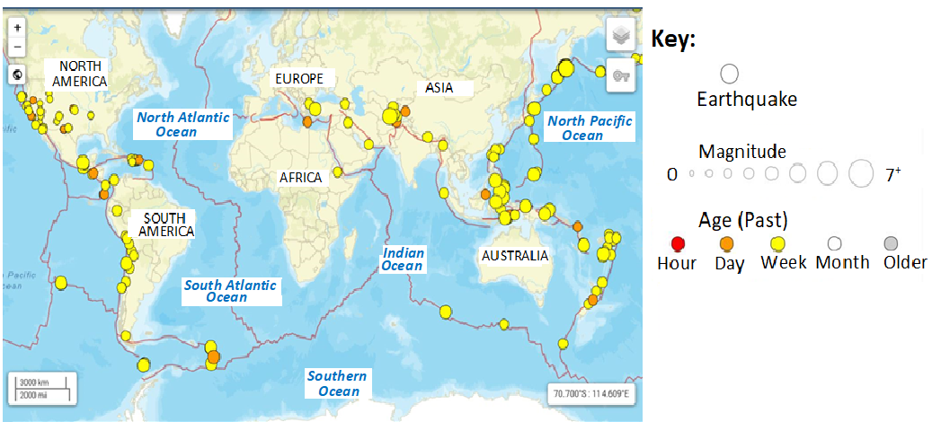
Fig.2: World map showing regions where earthquakes commonly occur
To reduce confusion, the Ministry of Disaster Preparedness and Refugees is planning to publish an article in one of the daily newspapers that will educate people about the science behind earthquakes, their effects and safety measures.
You have been asked, as a geographer, to write the article.
Task:
Write an article which will be published in the newspaper to address the issue.

Part II
Weather and Climate Systems

Attempt one item from this part.
Item 4:
Study the text and Fig 3 below; then do tasks that follow.
You are a Biogeographer studying a remote island ecosystem off the coast of west Africa. The island's climate is unusually mild for its latitude, and the surrounding waters contain a wide variety of fish species, including some that are not typically found in this region.
Recently, local fishermen have noticed changes in the types and distribution of fish they catch, though the cause is unclear. Some people (fisheries officers) believe that these changes are caused by shifts in ocean currents, which may be affecting the temperature and pH of the surrounding waters. Others think that human activities may be responsible for the changes.
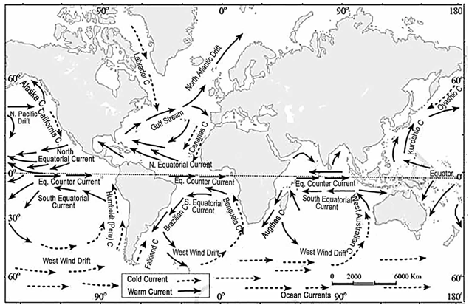
Fig. 3: Ocean currents of the World
You have been tasked with investigating the factors responsible for these conditions.
Tasks:
- Examine the characteristics and causes of the ocean currents affecting this region.

- Analyse the likely effects of these ocean currents on the physical environment and human activities in the adjacent lands?
Item 5:
Study the text and Fig 4 below; then do tasks that follow.
Recent studies in Ghana show that changing weather patterns are seriously affecting key sectors in the country such as agriculture, fisheries, health, and energy. Desertification is advancing at about 20,000 hectares per year, while rising temperatures (projected to increase by 1°C to 3°C by 2050 and 2.3°C to 5.3°C by 2080) threaten crop and fish production. Cocoa and rice yields are expected to fall, hydropower generation is at risk, and water-related diseases such as malaria and cholera are increasing. These impacts worsen poverty and slow national development.
As part of the Africa Continent Climate Action Campaign, the Ghana Meteorological Agency (GMet) has organised a competition for African secondary schools to propose strategies to help Ghana deal with and reduce the effects of changing weather patterns on affected sectors.
You have been selected by the Uganda Ministry of Education and Sports to represent the country in this contest, as a student environmental adviser. 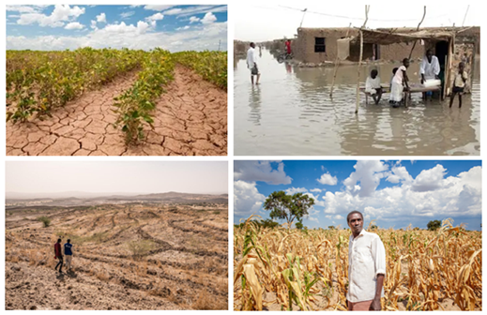
Figure 4: Some of the effects of the changing weather patterns
Tasks:
- Prepare detailed written advice for Ghana which you will present at the conference.
- What challenges do you think Ghana might face in implementing your advice?

P250/2
GEOGRAPHY
Paper 2
November/December, 2025
3 hours
Uganda Advanced Certificate of Education
Geography
Paper 2

Human Geography
3 hours

INSTRUCTIONS TO CANDIDATES:
This paper consists of two sections; A and B.
Section A is compulsory
Section B has two parts; I and II. Attempt one item from each part.
Attempt three items in all.
You may use relevant sketch maps, diagrams and statistics, where applicable, to illustrate your answers.
Any additional item(s) attempted will not be scored.
All to the items must be written in the answer booklet(s) provided

ADVICE
- Read the whole test item before answering it-especially if it is made up of more than one part.
- If you finish early, check your answers.

SECTION A

Application of Geographic Tools and Techniques to analysing Human environments

Item 1: Study the text, Tables 1.0 and 1.1; and Fig. 1 below then do the tasks that follow.
Urbanisation in Uganda is growing at a rate of 5.2% per year (National Population Council,2022). This rapid growth puts pressure on the environment, urban facilities, and makes it harder to control and development. Planning is very important because it determines how, when, and where development takes place. However, this is only possible with reliable data on each urban area; data the Ministry of Lands, Housing and Urban Development currently lacks.

To promote orderly growth and improve living conditions, the Ministry has engaged various data collectors, including Advanced Secondary Geography learners.
During a fieldwork study of one of the country’s cities, the learners collected and presented data on land use zones and their characteristics, the proportion of residents in each zone, and the employment status of city residents. Their findings are shown in Tables 1.0, 1.1; and Fig. 1.

The Ministry has requested you, as an Urban Geographer, to analyse this data and recommend ways to improve land use and living conditions in the city.

Table 1.0: Land use zones in the city and their characteristics

Zone & Distance from the Centre (km) | Central Business District (CBD)  (0-1km) | Inner city (2-4 km) | City suburbs (5-6 km) | Urban fringe  (7-9 km)
Land use | Shopping malls, offices, hotels, theatres and entertainment halls | High class housing, Amenity forestry, Leisure parks | Medium class housing, Slum settlements, Squatter settlements, Light manufacturing, Warehousing, Backyard gardening | Low-cost tenement housing, Squatter settlements, Heavy manufacturing, Warehousing, Intensive farming
Nature of buildings | High-rising, Permanent | Multi-storied, Permanent | Bungalows, Tenement houses, Temporary/Makeshift shelter | Bungalows, Tenement houses, Temporary/Makeshift shelter
Density of building | Very high-density building | Medium- density building | High density building | Very high-density building
Amenities | 100% access to piped water, sewerage system, electricity, garbage skips | 100% access to piped water, sewage system, electricity, garbage skips | 40% access to piped water, sewerage system, electricity, garbage skips | 10% access to piped water, sewerage system, electricity, garbage skips
Nature and state of road network | First class tarmac roads, High density, Fair conditions | First class tarmac roads, High density, good conditions | Few tarmac roads, Many bound surface roads and loose surface motorable tracks, Poor state with several potholes | Only main roads are tarmac, Majority are bound surface roads, many loose surface motorable tracks, Poor state with many potholes
Vegetation cover | Scanty and isolated amenity trees, other decorative plants along major avenues | Scattered amenity trees, other decorative compound plants | Very few preserved natural trees, remnants of wetland vegetation | Very few preserved natural trees, remnants of wetland vegetation

Table 1.1: Proportion of residents living in each city zone

ZONE | Population | Percentage of total Population
Central Business District (CBD) | 240,000 | 8.6%
Inner city | 364,000 | 13.1%
City suburbs | 1,120,000 | 43.2%
Urban fringe | 973,000 | 35.1%
Total | 2,773,000 | 100%
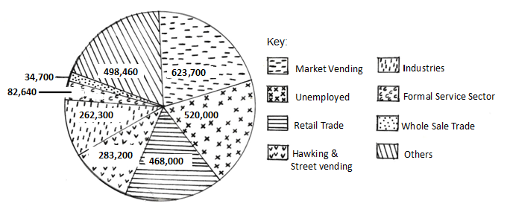
Fig. 1: Employment of City residents by category of work

Tasks:
Use only the information provided in the scenario, tables, and figure to answer the following tasks.
- Determine the Objectives that the team followed while carrying out the study.
- Giving relevant evidence, explain the methods and tools which the team likely used to collect data during the fieldwork study.
- Based on your analysis of the findings, advise the Ministry of Lands, Housing and Urban Development on realistic ways to improve land use and living conditions in the city.

SECTION B: Human- Environment Interaction

Part I

ITEM 2: Study the text, Fig. 2 and Table 2.0 below then do the task that follows.

The African Union has reported that approximately 20% of the population in Sub-Saharan Africa suffers from hunger, with some countries experiencing severe food shortages, as shown in Fig. 2 and Table 2.0. For example, in South Sudan, over 7 million people are facing acute food insecurity. The effects of these shortages are far-reaching with increased malnutrition, reduced economic productivity, and social unrest.

African leaders and food experts still disagree on how to solve the continent’s low farm productivity and ongoing food shortages. Some believe the answer is to use modern, western-style farming methods, while others think increasing the amount of land used for farming is the best solution.

As one of the food production and distribution experts in your country, you have been chosen to attend the 2025 African Food Summit in Addis Ababa, Ethiopia. The theme of the summit is “Addressing low farm productivity in Africa; a sure way of ending food shortages in Sub-Saharan Africa”.

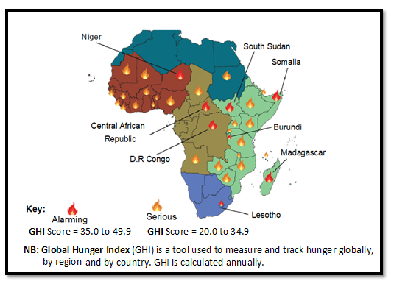
Fig 2: Food crisis in Africa
Table 2.0: Prevalence of Undernourishment in Selected African Countries (2019-2023)

 | 2019 (%) | 2020 (%) | 2021 (%) | 2022 (%) | 2023 (%)
South Sudan | 45.6 | 47.2 | 50.1 | 52.5 | 55.3
Somalia | 38.2 | 40.5 | 42.9 | 45.1 | 47.4
Nigeria | 12.1 | 13.4 | 14.8 | 16.2 | 17.5
Ethiopia | 23.5 | 25.1 | 26.8 | 28.5 | 30.2
DRC | 30.1 | 32.2 | 34.3 | 36.4 | 38.5

Task:
Based on the theme, write a detailed essay which you will present to the African leaders at the summit.

Item 3: Study the text, Table 3.0 and Fig. 3 below then do the tasks that follow.
The world’s population has reached 7.9 billion, with great differences in its distribution, growth and structure, among countries. For example, Japan and Italy are experiencing low fertility rates and ageing populations, while Niger and Somalia have high fertility rates and young populations. These differences in population characteristics greatly affect resource utilisation, development, and environmental sustainability. However, many Least Developed Countries (LDCs) still do not pay enough attention to population issues when planning for development. The relationship between population and development is shown in Table 1.

Table 3.0: Population and Development Indicators for Selected Countries

Country | Population Size (2023) | Population Growth Rate (%) | Human Development Index (HDI) | GDP per capita (USD)
Japan | 123 million | -0.3 | 0.915 | 44,914
Italy | 60 million | -0.1 | 0.895 | 39,637
Niger | 25 million | 3.2 | 0.394 | 601
Somalia | 16 million | 2.9 | 0.361 | 434

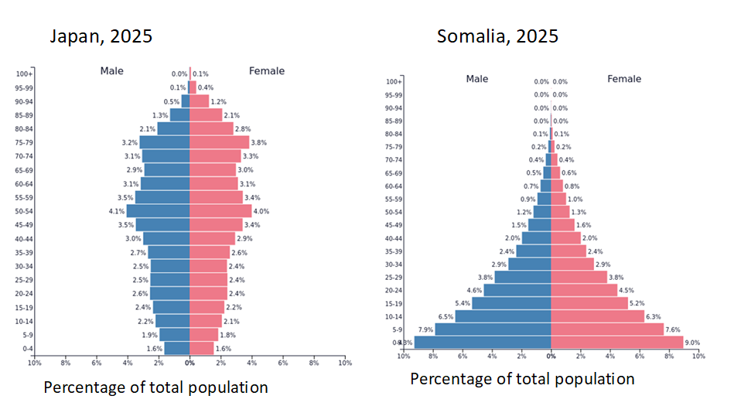
Fig.3: Population structures for Japan and Somalia
Adapted: https://www.populationpyramid.net/spain/2020/

Tasks:
- Using data from Table 1, draw a suitable statistical diagram to show the relationship between population size and GDP per capita for the selected countries.
- Basing on Table 1, account for the great differences in population characteristics between the developed and developing countries.
- Giving evidence from the above scenario and Fig. 2, help Japan and Somalia to understand how their population structures might affect resource utilisation and national development.

Part II
Sustainable Use of Natural Resources
Attempt one item from this part.

Item 4
Study the text and Fig. 4 below then do the tasks that follow.
A rural district in Western Uganda is facing growing pressure on its natural resources including landscape, soils, forests, rivers and wetlands. Over the past years, several areas that were once fertile have become less productive. Meanwhile, the demand for land and energy has increased with population growth. This situation is worrying to several community members who have expressed the need for an immediate solution. The District Environment Committee would like to create awareness in the community on ways of addressing the situation.
The District Environment Committee has requested your school Geography club to help create community awareness about the situation.
As a member of the club’s Environment Awareness Team, you are responsible for preparing materials and giving a short presentation to guide community discussions on how to manage the affected natural resources more sustainably.
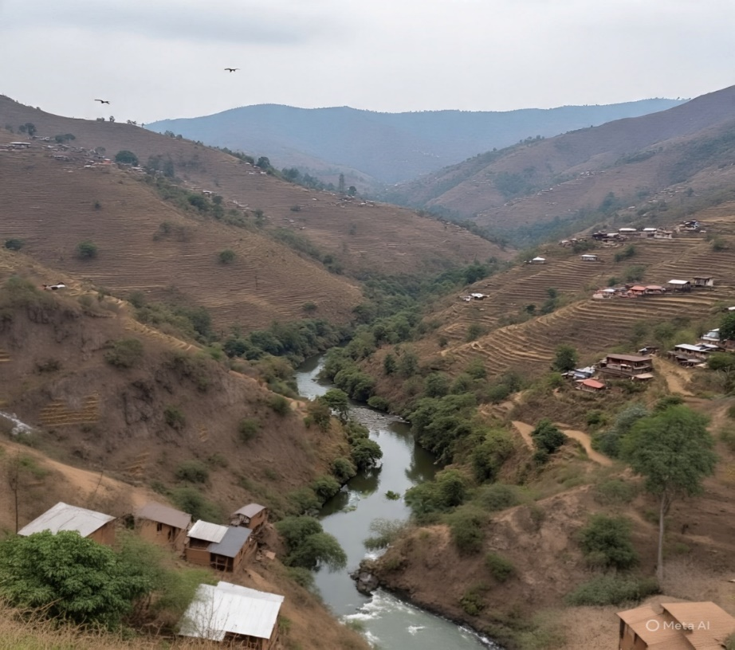
Fig. 4: One of the areas in the rural district

Tasks:
- Using the photograph (Fig. 4), draw a suitable diagram to show the main land use types and areas at risk of environmental degradation.
- Propose ways of utulising the district’s natural resources that are facing a danger of getting degraded sustainably.

Item 5: Study the text and Fig. 5 below then do the tasks that follow.
You are an environmental advisor to the local council in your city. One of the city’s rapidly growing suburbs lies close to a critical wetland that is crossed by a major river feeding into the main drainage system of the country. The wetland is under threat.
In recent months, human activities have increased greatly in the area. A new informal settlement is expanding along the wetland edge, and a private investor wants to build a shopping complex and parking lot within the wetland. At the same time, local residents depend on the wetland for harvesting plant materials, water for domestic and other uses, small-scale vegetable farming, and even disposal of liquid and solid domestic waste.

As a result, the wetland is being degraded, water flow is getting blocked, and the river’s quality is declining. Yet, stopping all human activities would negatively affect people’s livelihoods and economic opportunities. The local council is concerned about this situation and has called a meeting to find a balanced solution that promotes development, community livelihoods and environmental conservation.
You have been invited to present your advice at the meeting.

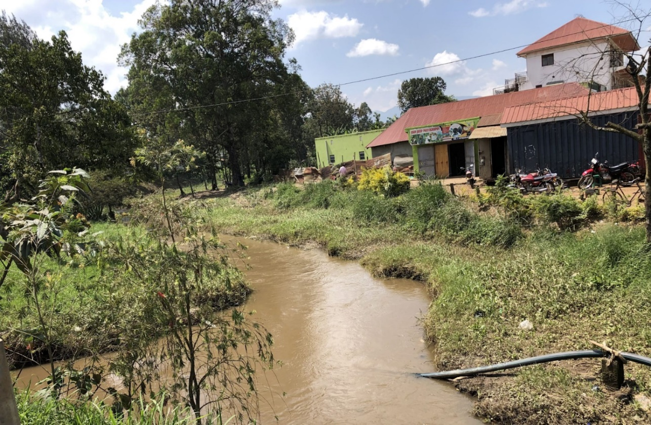

Fig.5: The critical wetland and rapidly growing city suburb
Task:
Assess the situation in the area and propose a plan for sustainable utilisation of resources and development which you will present at the meeting.

End

